WEB ASSIGNMENT 2

Sreeram SP

S6R1

24

1. Create an XHTML document that contains at least 5 lines of text from a newspaper story. Every verb in the text must be green, every noun must be blue , &amp; every preposition must be yellow.

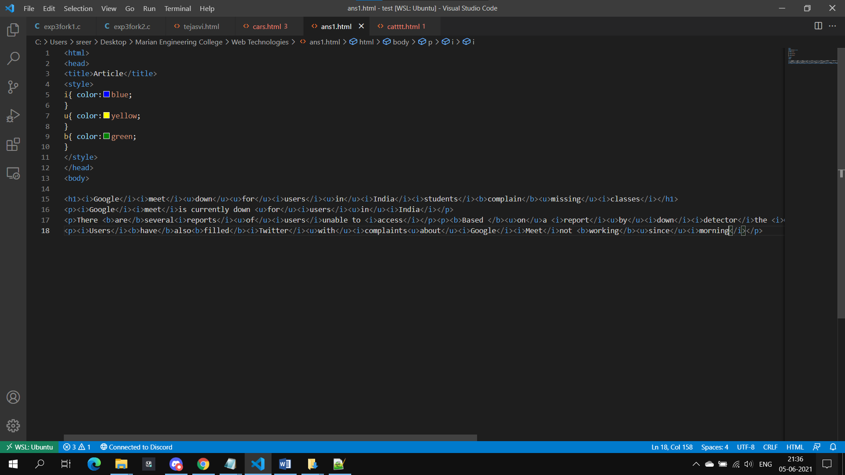

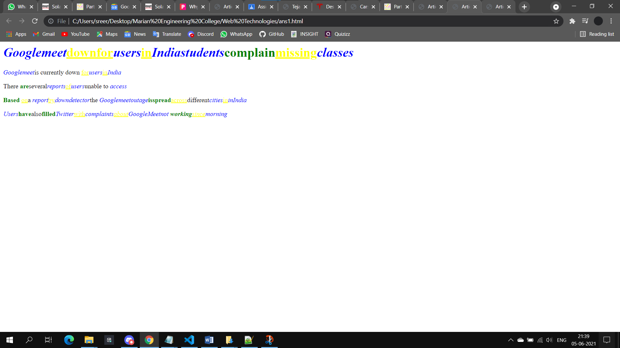

1. Design an Online Registration Form for Tejasvi-21 (Use all Widgets in HTML forms &amp; CSS)

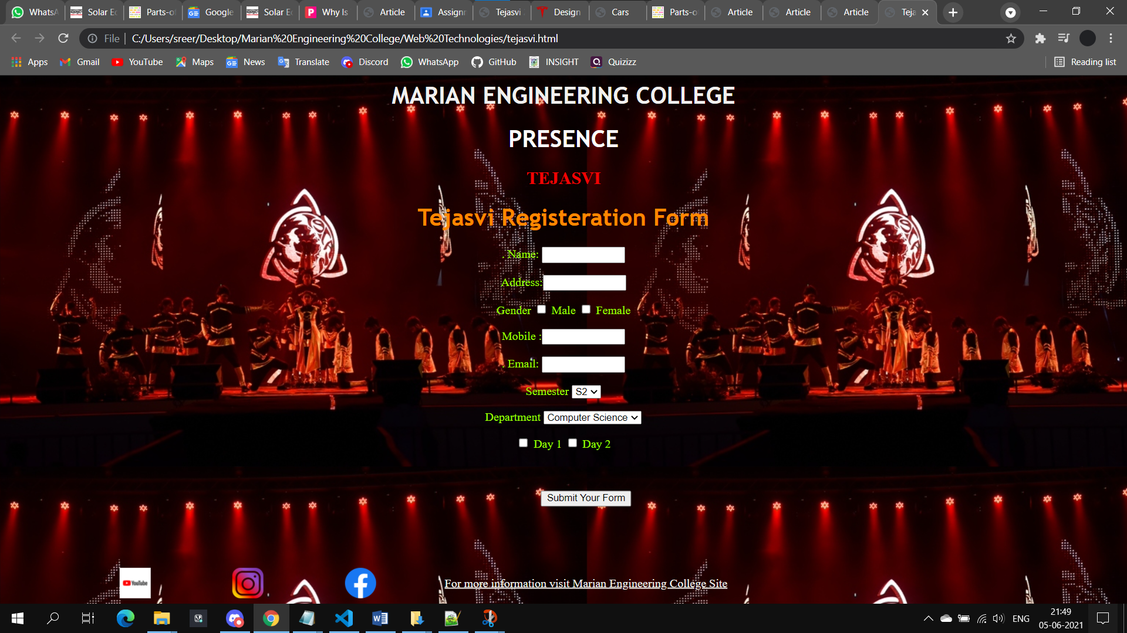

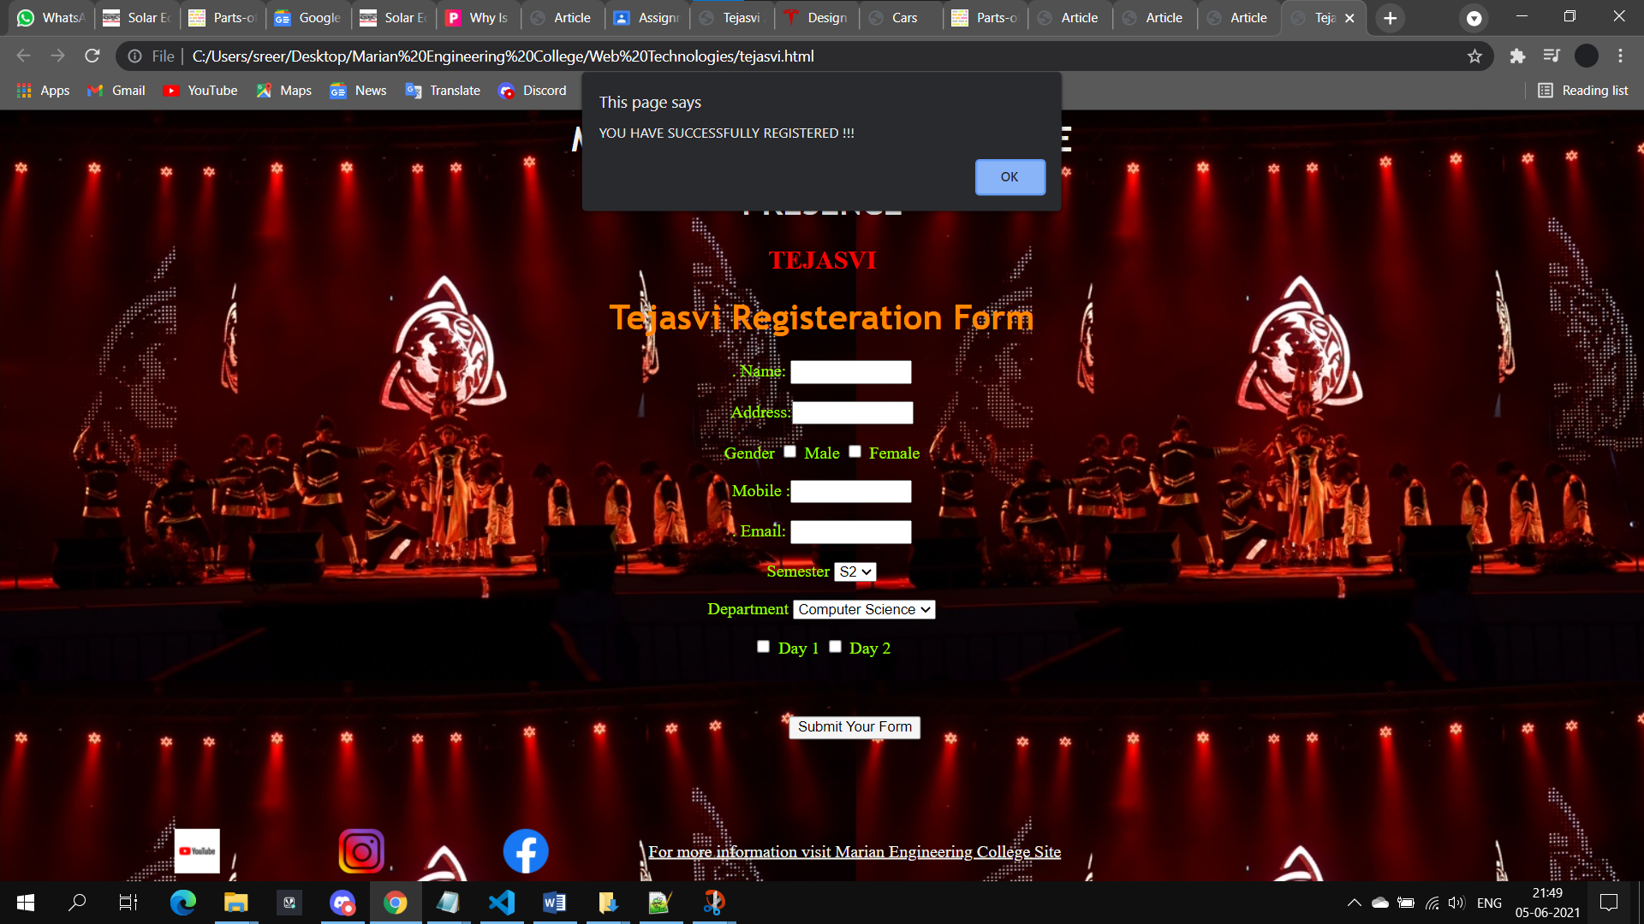

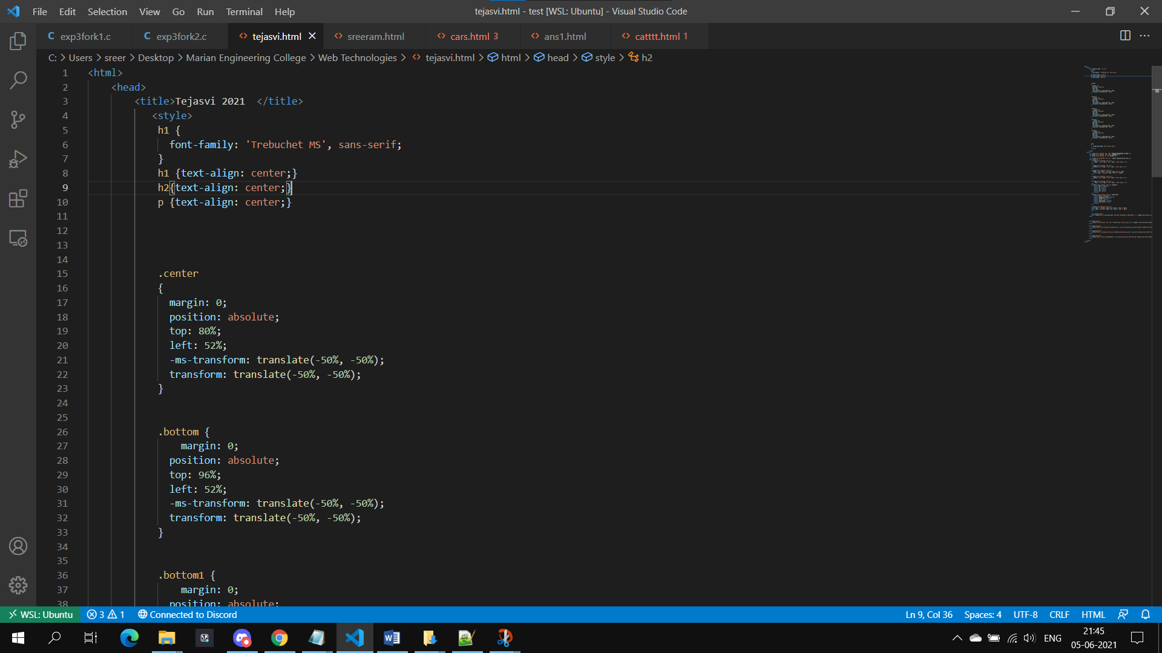

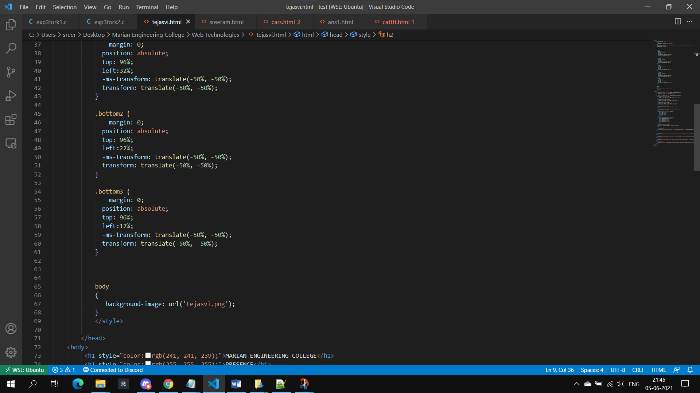

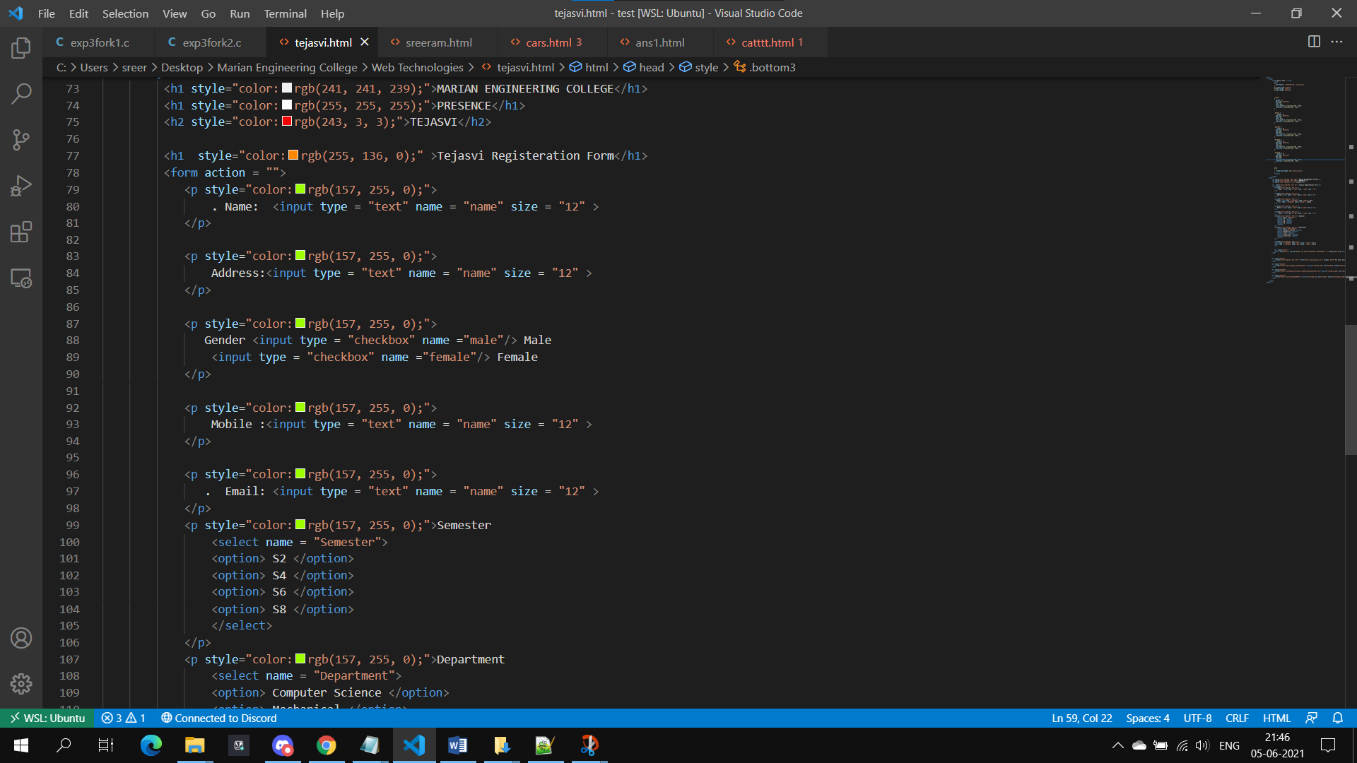

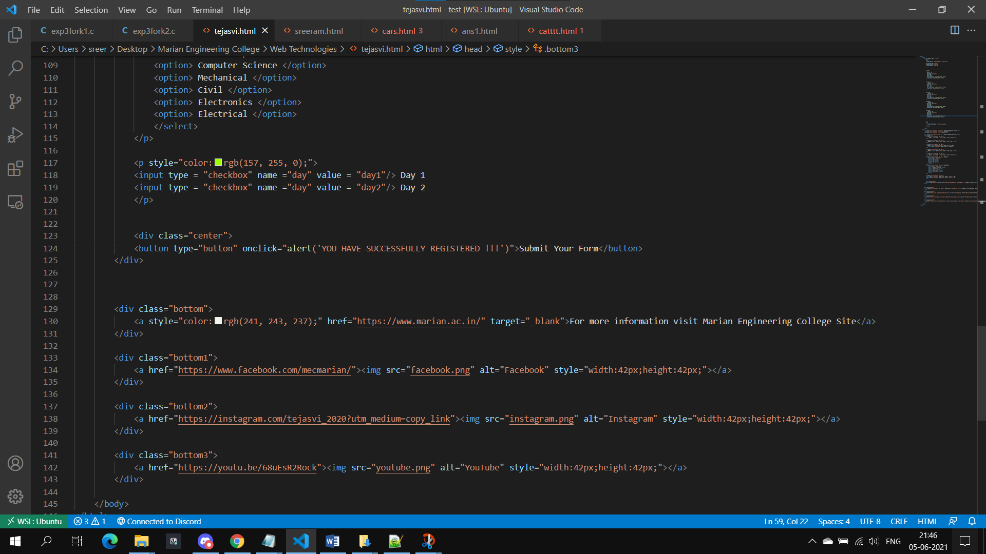

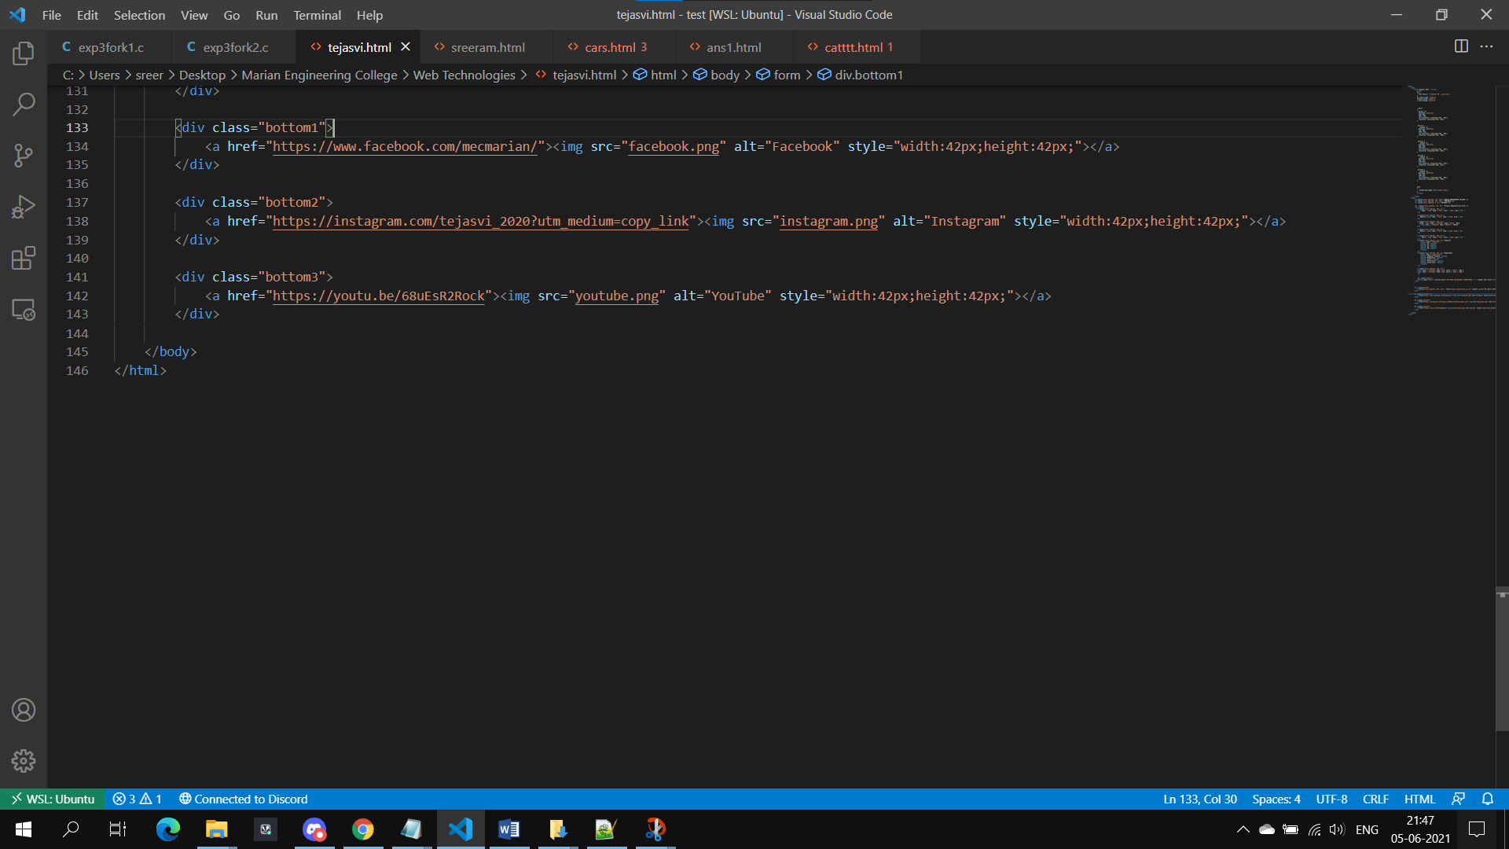

1. Create a Web Page for online car shopping (use almost all tags you have studied in HTML &amp; CSS)

